**CHEMISTRY REFERENCE TABLES**

**Table 2 – Prefixes**

**Table 1 -Common Units**

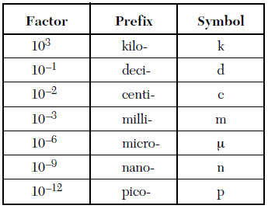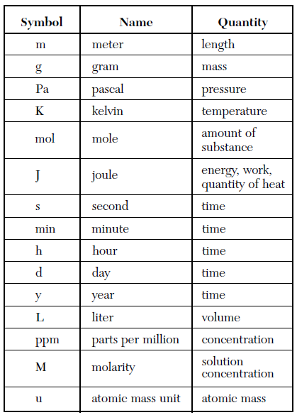

**Table 4 -STP**

|  |  |
| --- | --- |
| **Mass** | **Length** |
| 1 lb = 435.6 g | 1 inch = 2.540 cm |
| 1 oz = 28.35 g | 1 ft = 30.48 cm |
| 1 kg = 2.2 lbs | 1 m = 3.28 ft |
| 1 ton = 1000.kg | 1 mi = 1.609 km |
| 1 lb = 16 oz | 1 ft = 12 in |
| 1 ton = 2000 lbs | 1 yd = 3 ft |
|  | 1 mi = 5280 ft |
|  | |
| **Volume** | **Temperature** |
| 1 fl oz = 29.57 mL | K = ˚C + 273 |
| 1 L = 1.057 qt | ˚C = $\frac{5}{9}$ (˚F – 32) |
| 1 gal = 3.758 L | ˚F = $\frac{9}{5}$ (˚C +32) |
| 1 in3 = (2.54 cm)3 |  |
| 1 qt = 2 pt |
| 1 gal = 4 qt |

**Table 3 – Conversions**

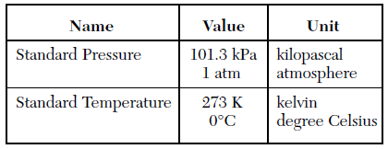

**Table 5 –Energy and Pressure**

|  |  |
| --- | --- |
| **Energy** | **Pressure** |
| 1 cal = 4.184 J | 1 atm = 760 mmHg = 760 torr = 101.3 kPa = 14.7 psi |

SOURCE: THE UNIVERSITY OF THE STATE OF NEW YORK • THE STATE EDUCATION DEPARTMENT• ALBANY, NY 12234

**Formulas and Constants**

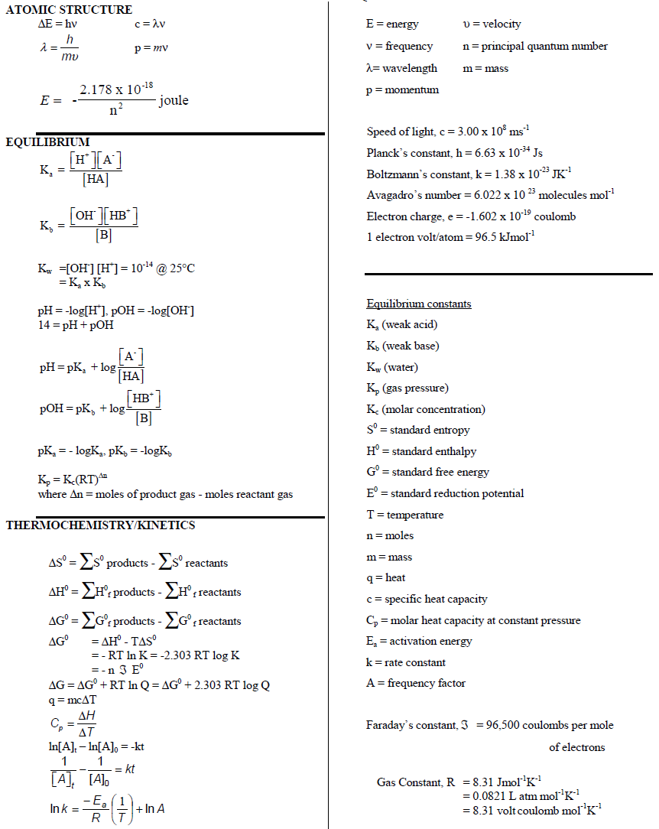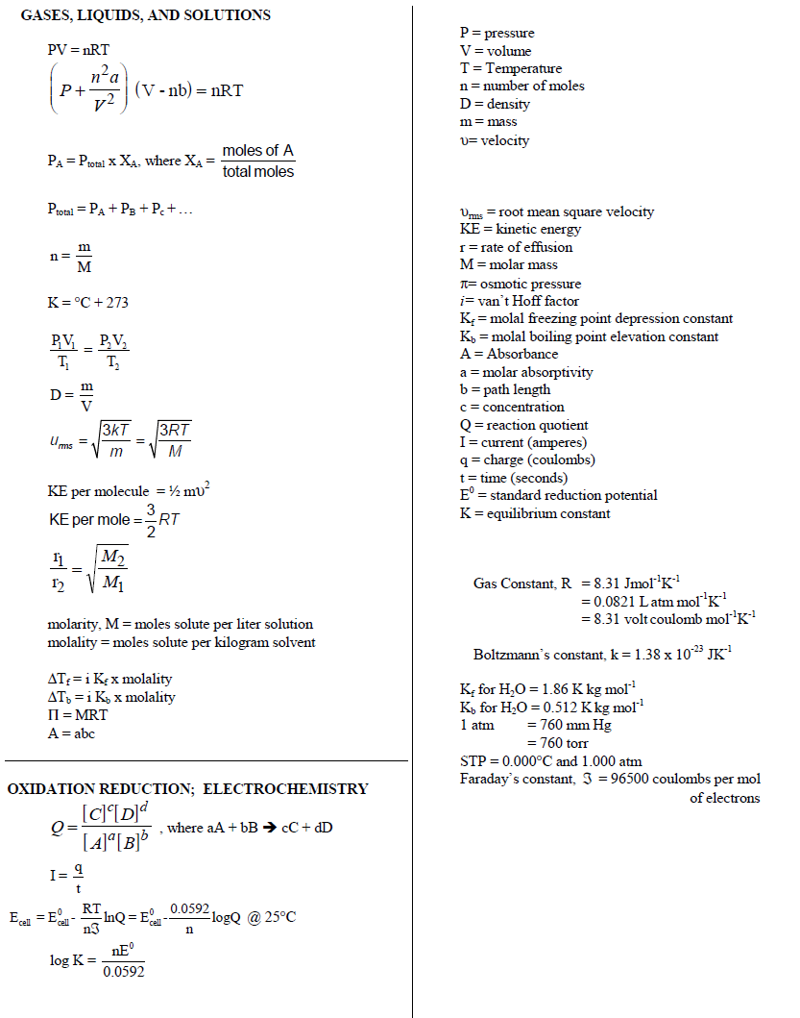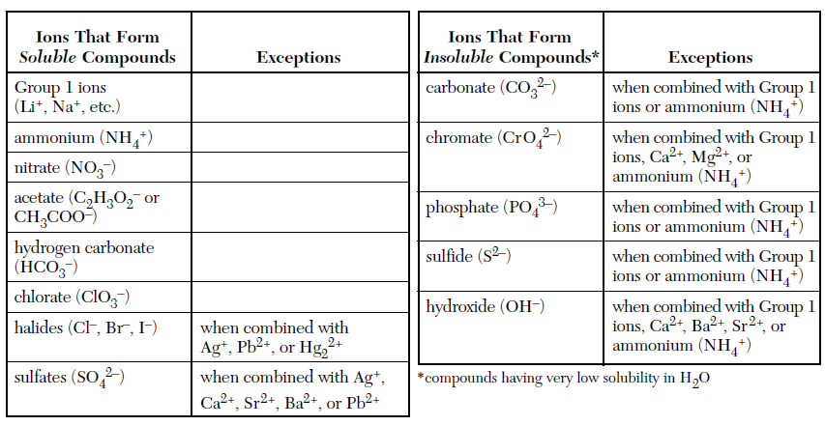

**Table 6 –Solubility Rules**

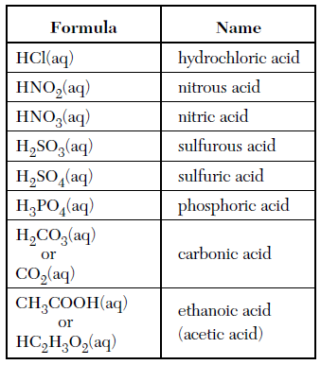

**Table 8 –Common Acids**

**Table 7 –Water Properties**

|  |  |
| --- | --- |
| **Density of Water** | **1.00 $\frac{g}{L}$** |
| **Specific Heat of Water**  **( Cor Cp or Csp)** | **1.00 $\frac{cal}{g ˚C}$ or 4.18 $\frac{J}{g˚C}$** |
| **Latent Heat of Fusion of Water**  **( ΔHfus)** | **80 $\frac{cal}{g }$ or 334 $\frac{J}{g }$** |
| **Latent Heat of Vaporization of Water (ΔHvap)** | **540 $\frac{cal}{g }$ or 2260 $\frac{J}{g }$** |

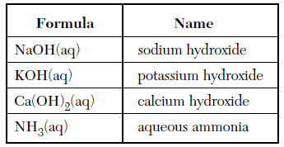

**Table 9 –Common Bases**

SOURCE: THE UNIVERSITY OF THE STATE OF NEW YORK • THE STATE EDUCATION DEPARTMENT• ALBANY, NY 12234

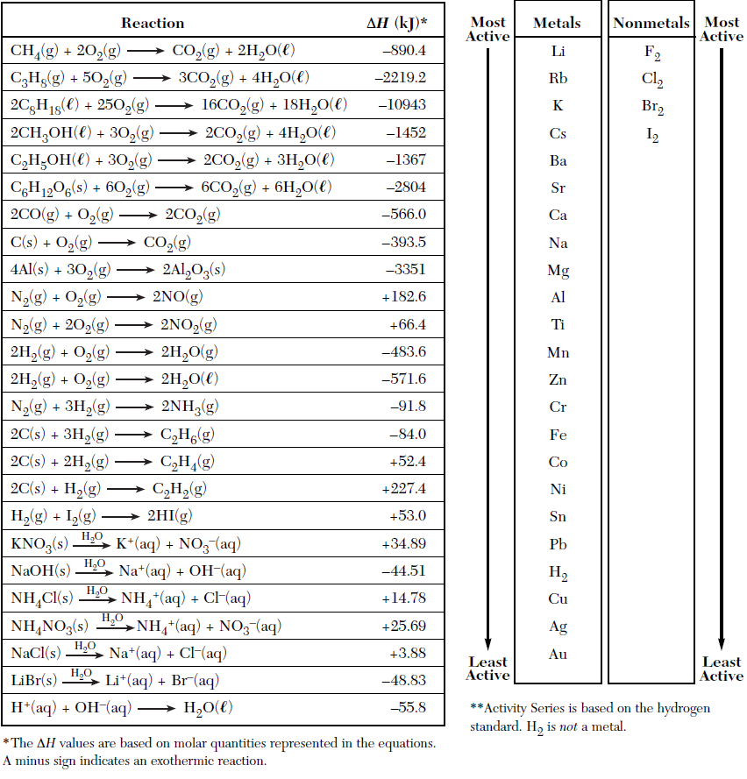

**Table 11 –Activity Series**

**Table 10**

**Heats of Reaction at 101.3 kPa and 298 K**

SOURCE: THE UNIVERSITY OF THE STATE OF NEW YORK • THE STATE EDUCATION DEPARTMENT• ALBANY, NY 12234

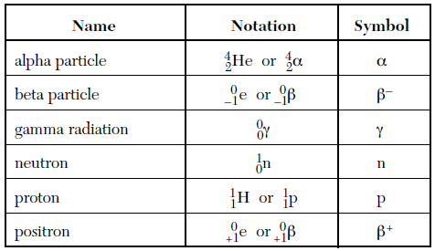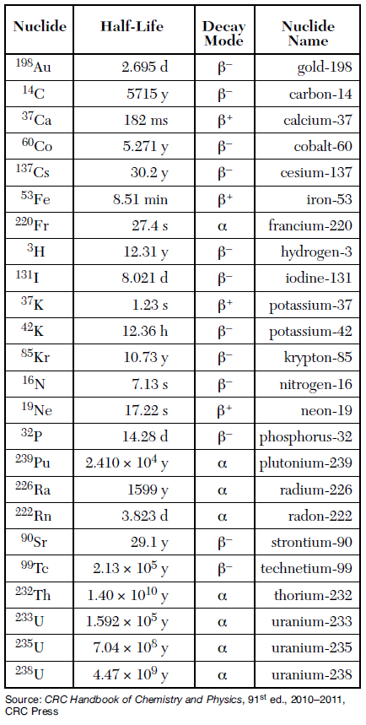

**Table 13 –Radioisotopes**

**Table 12 –Half-Life**



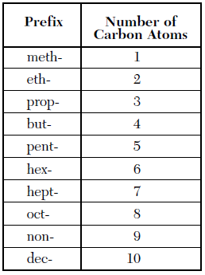

**Table 14- Organic Prefixes**

|  |  |
| --- | --- |
| Mono- | 1 |
| Di- | 2 |
| Tri- | 3 |
| Tetr(a)- | 4 |
| Pent(a)- | 5 |
| Hex(a)- | 6 |
| Hept(a)- | 7 |
| Oct(a) - | 8 |
| Hept (a)- | 9 |
| Dec(a)- | 10 |

**Table 15- Covalent Prefixes**

**Table 16 –Solubility Product Constant @ 25˚C**

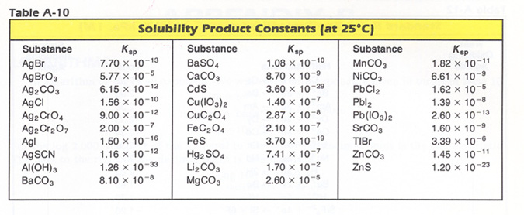

**Table 18- Bond Length and Energy**

**Table 17 – Heat of Combustion of Hydrocarbons**

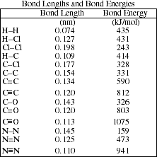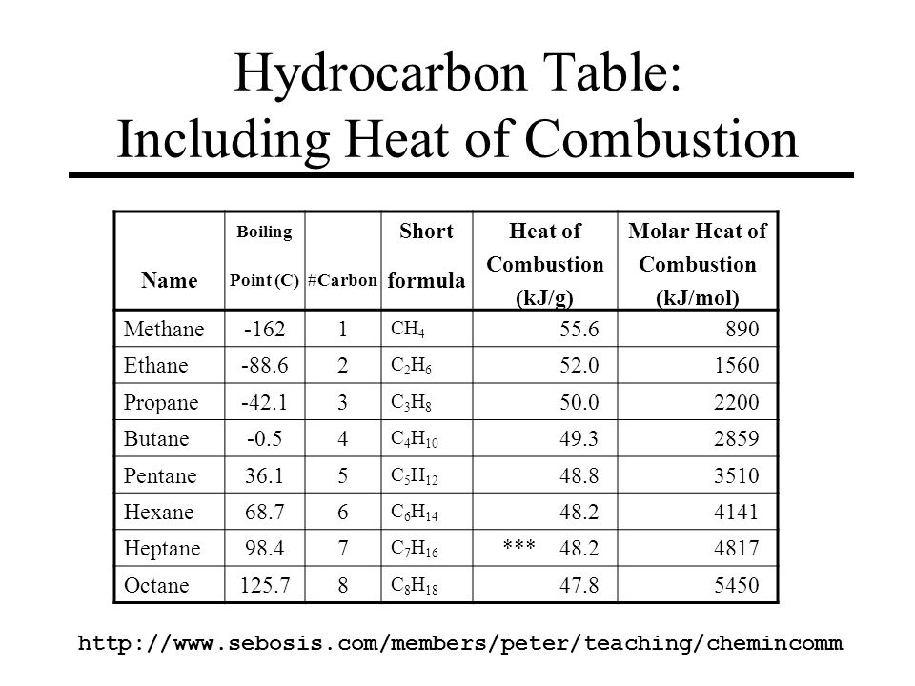

**Table 17 – Bond Length and Energy**

**Table 19 – Heat of Formation and Entropy of Organics**

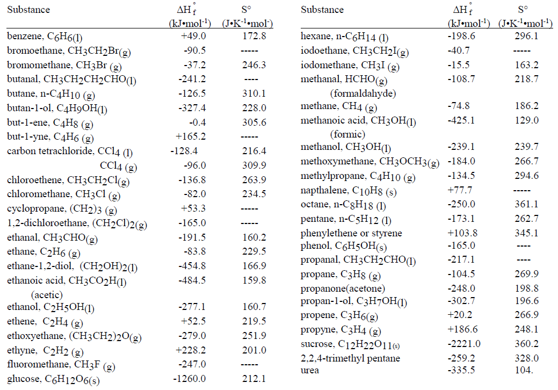

**Table 20 – Heat of Formation, Entropy and Gibb’s Energy of Inorganics**

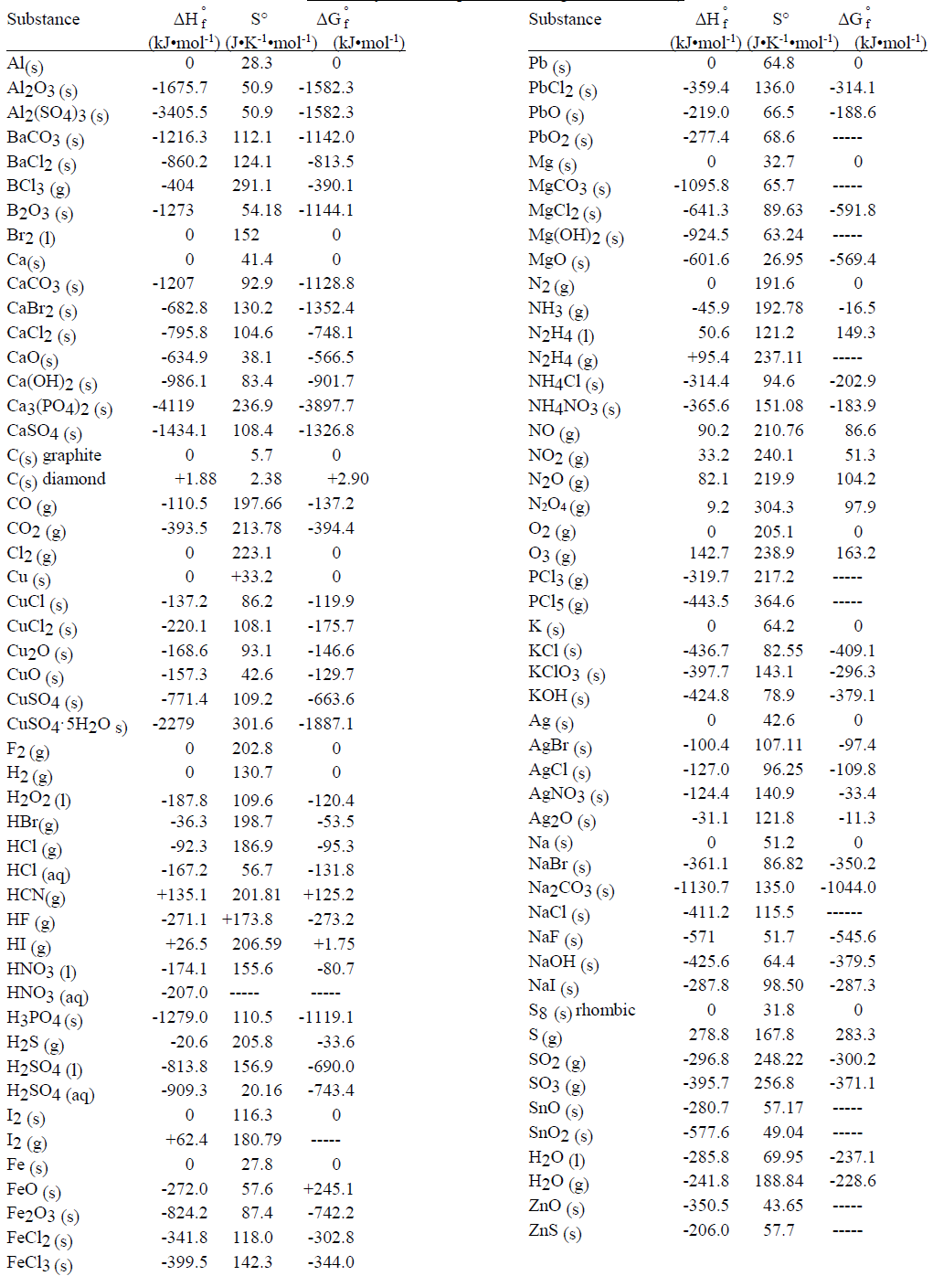

Fe3O4 (s) ‐1118.38 146.44 ‐1015.46

NaHCO3 ‐947.68 102.09 ‐851.86

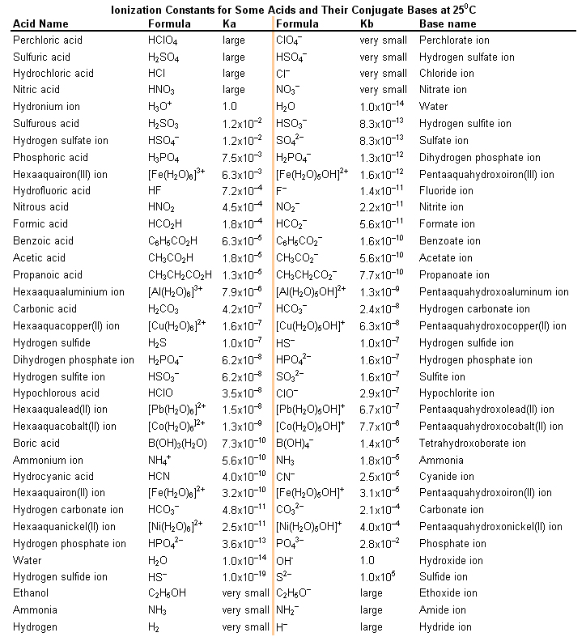

**Table 21 - Ionization Constants for Acids and Bases @ 25⁰C**

**Table 22 – Solubility of Compounds**

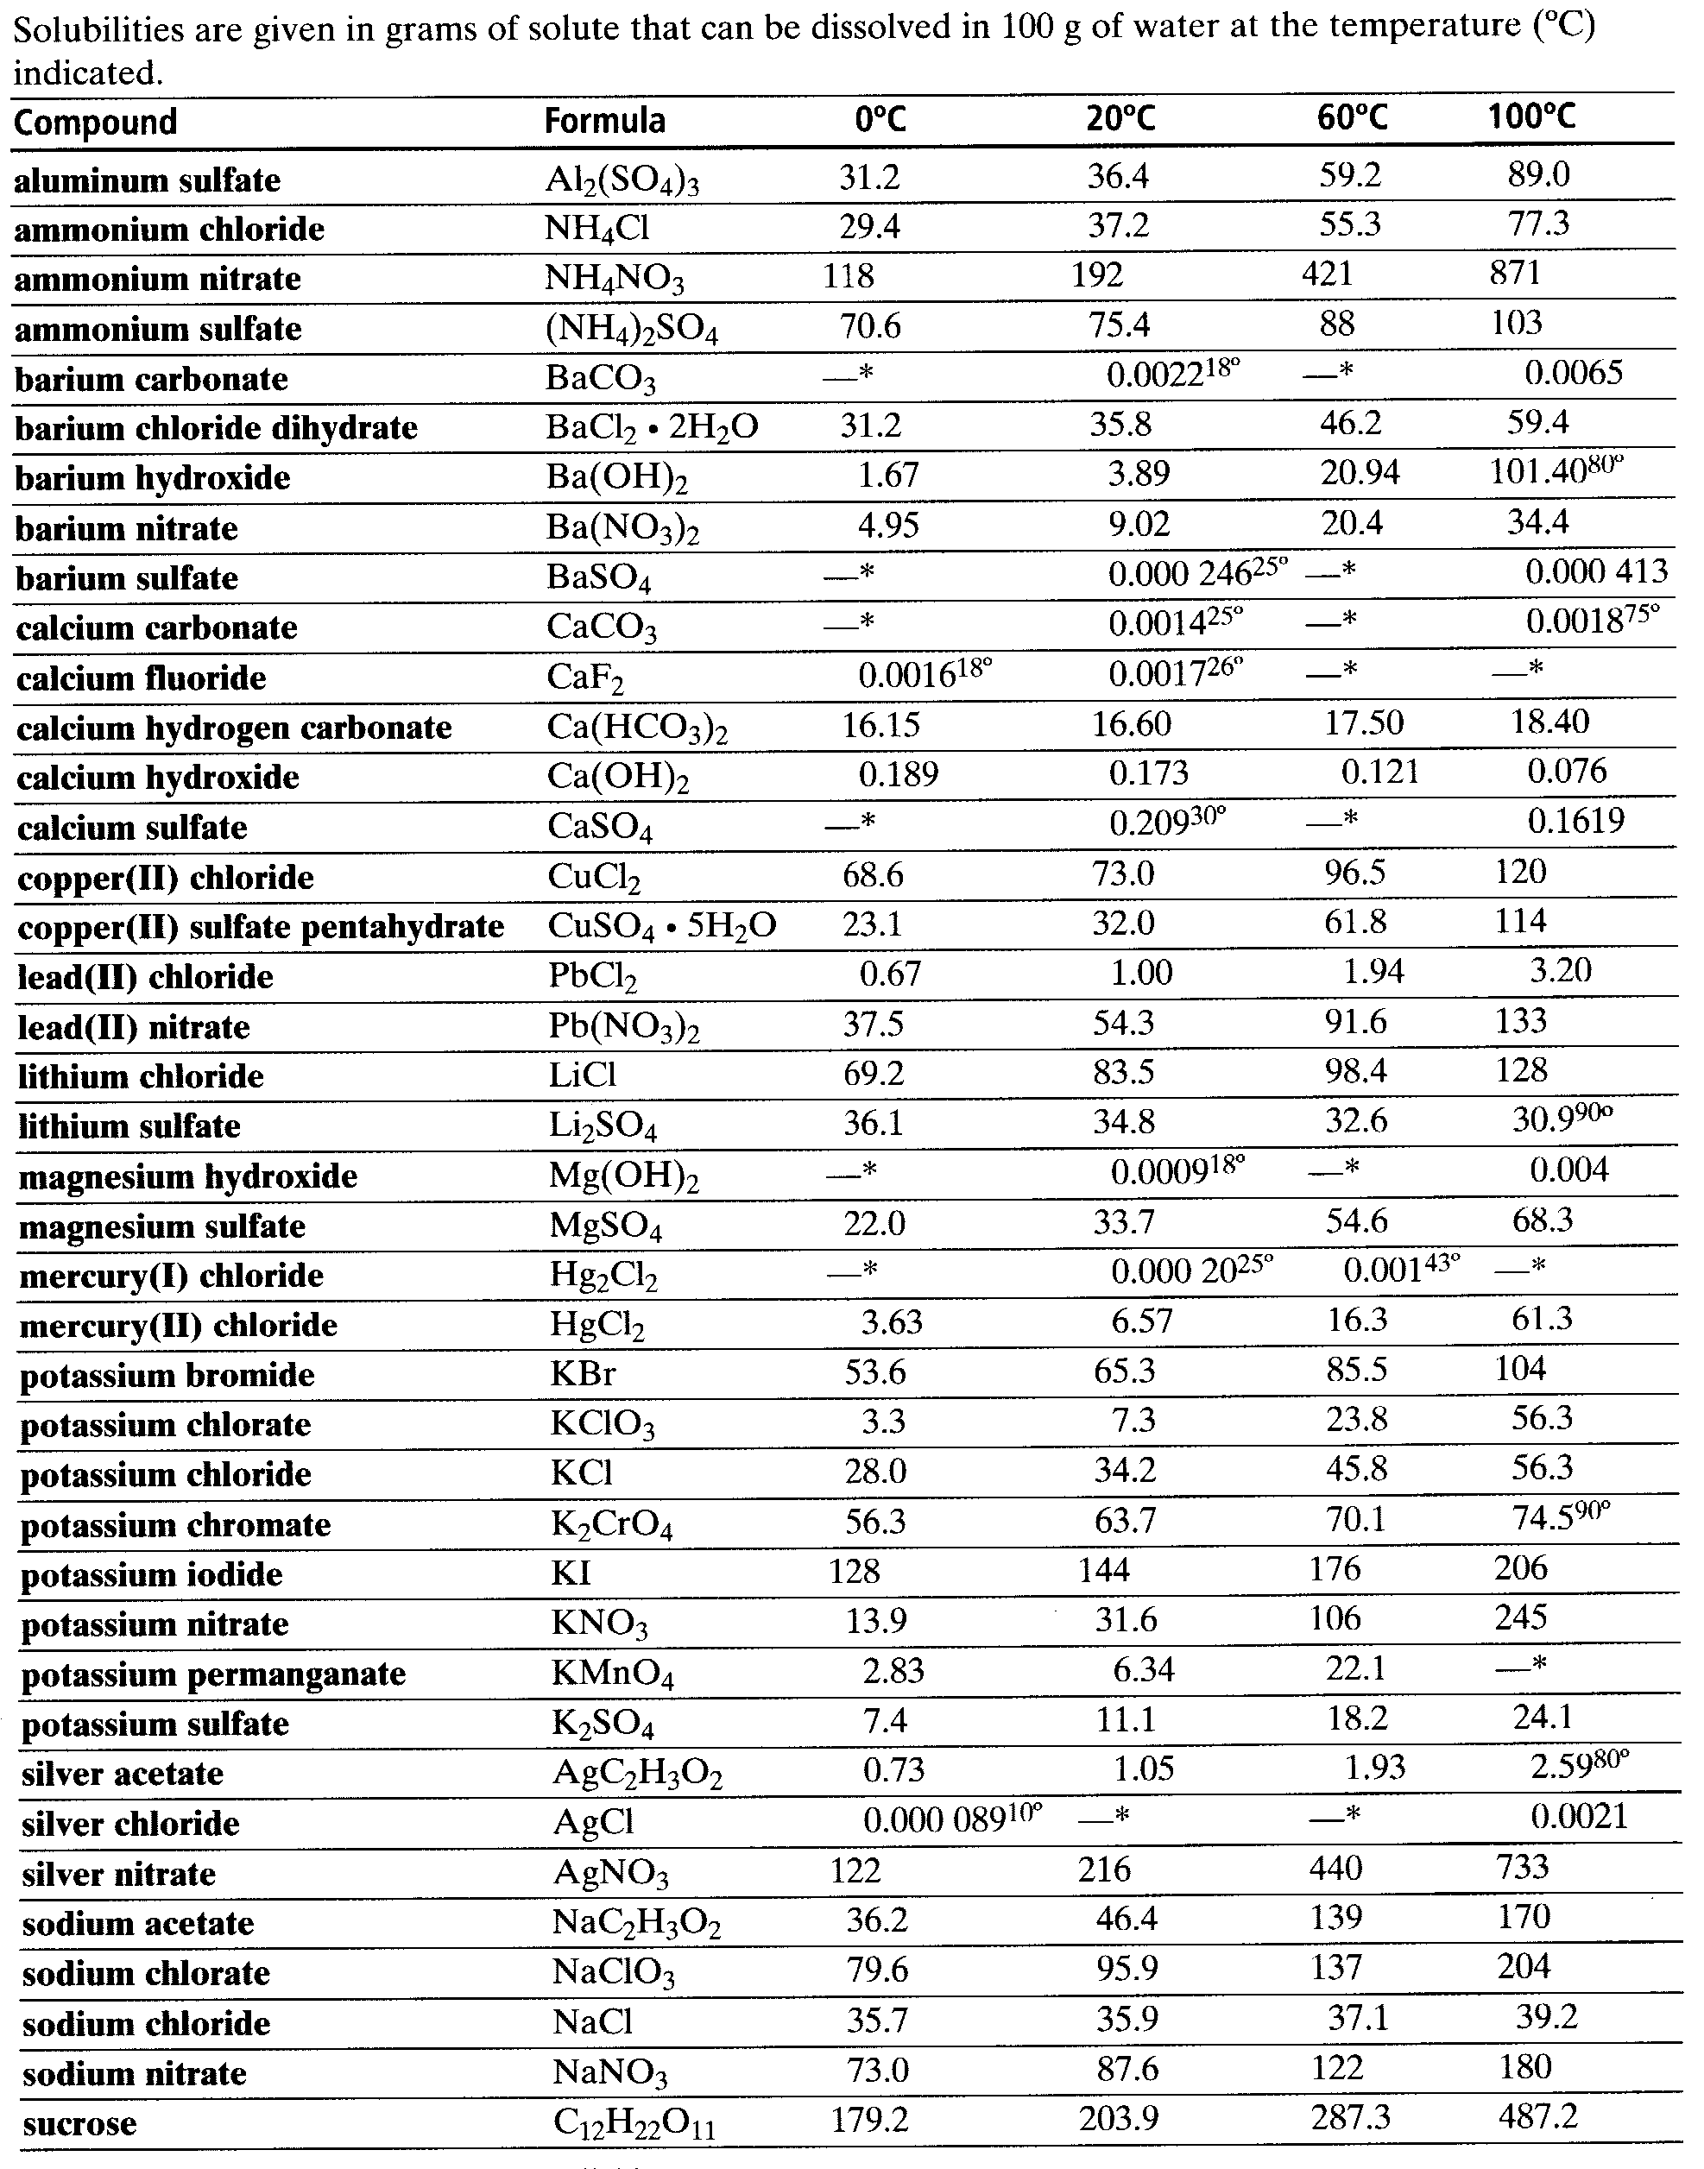

**Table 23**

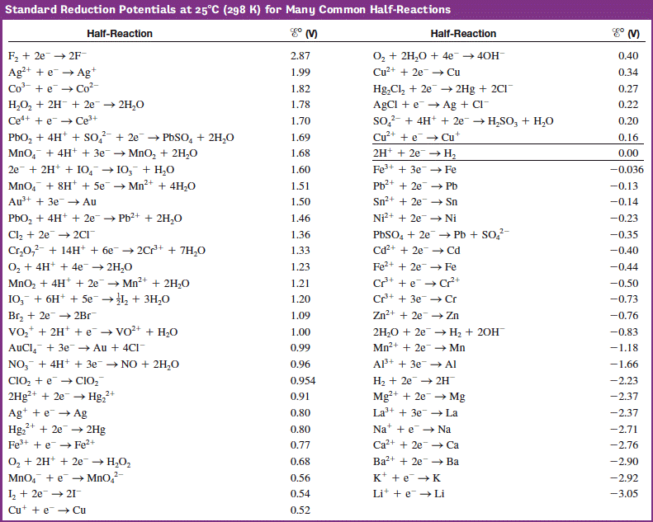**Standard Reduction Potential at 25˚C for Common Half Reductions**

**Table 24- Solubility Curve at Standard Pressure**

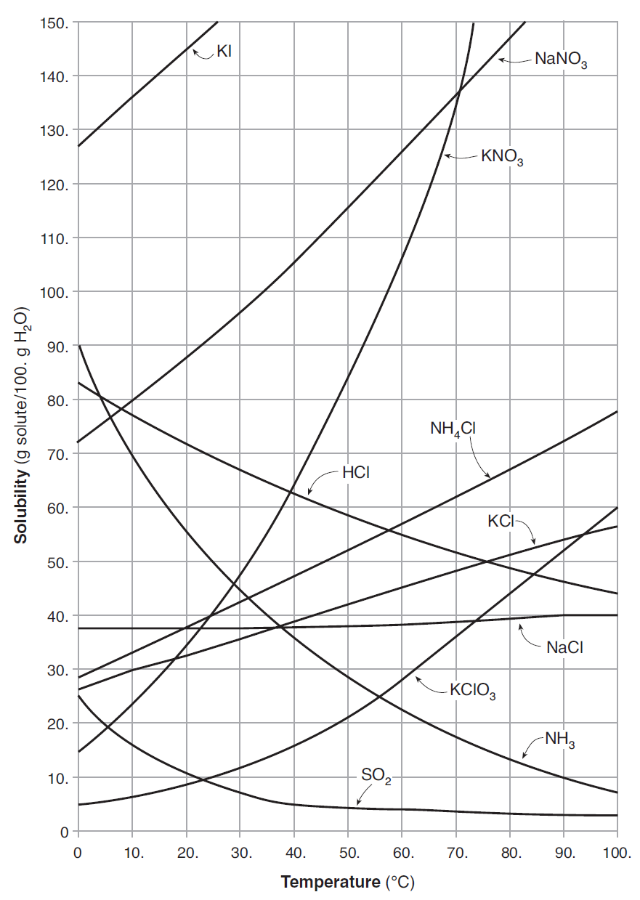

**Reference Tables for Physical Setting/Chemistry – 2011 Edition**

**Table 25- Vapor Pressure of 4 Liquids**

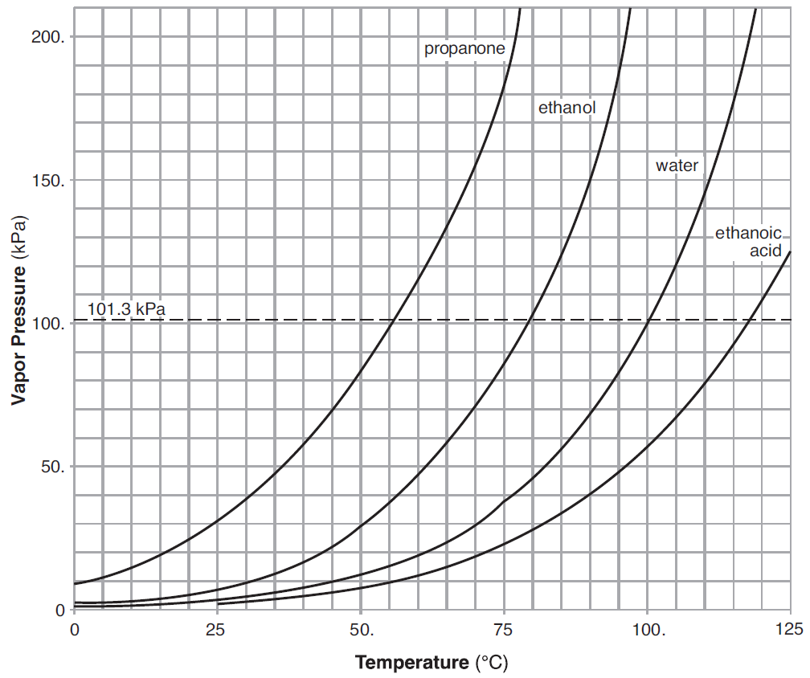

**Reference Tables for Physical Setting/Chemistry – 2011 Edition**

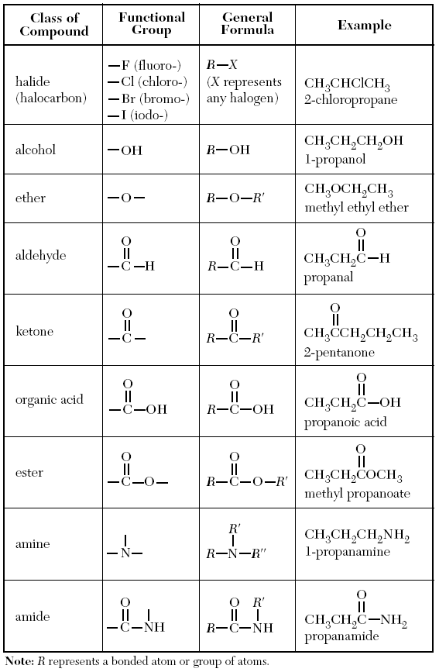**Table 26 – Organic Chemistry**

